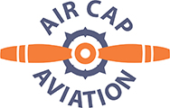

Good Faith Estimate – Private Pilot Training Costs

AirCap Training Costs
45 hours C-172 - $7256
6 hours RedBird Simulator - $180
39 hours flight/sim training - $2535
25 hours one-on-one ground - $1625
Course Registration Fee - $185
____________________
TOTAL AirCap $11,781

Possible Third-Party Fees
FAA Medical - $150
Knowledge Exam Fee - $250
Check Ride Fee - $650
_____________________
TOTAL 3rd Party $1050

